**HELPING HAND: AI-DRIVEN MEDICAL SYSTEM**

**GE19612 - PROFESSIONAL READINESS FOR INNOVATION, EMPLOYABILITY AND ENTREPRENEURSHIP PROJECT REPORT**

***Submitted by***

**RAGUL SOWMIYANARAYANAN GK (2116220701284)**

**SURANJANA S (2116220701293)**

**VIDYALAKSHMI E (2116220701316)**

***in partial fulfillment for the award of the degree of***

**BACHELOR OF ENGINEERING**

***in***

# 

# COMPUTER SCIENCE AND ENGINEERING

**RAJALAKSHMI ENGINEERING COLLEGE ANNA UNIVERSITY, CHENNAI**

MAY 2025

RAJALAKSHMI ENGINEERING COLLEGE, CHENNAI

**BONAFIDE CERTIFICATE**

Certified that this Project titled **“ Helping Hand: AI - Driven Medical System”** is the bonafide work of **“Ragul Sowmiyanarayanan G K (2116220701284), Suranjana S(2116220701293), Vidyalakshmi E(2116220701316)”** who carried out the work under my supervision. Certified further that to the best of my knowledge the work reported herein does not form part of any other thesis or dissertation on the basis of which a degree or award was conferred on an earlier occasion on this or any other candidate.

# SIGNATURE

## Dr. P. Kumar., M.E., Ph.D.,

**HEAD OF THE DEPARTMENT**

Professor

Department of Computer Science and Engineering,

Rajalakshmi Engineering College, Chennai - 602 105.

# SIGNATURE

## Dr. SenthilPandi .,M.E., Ph.D.,

## SUPERVISOR

Assistant Professor

Department of Computer Science and Engineering,

Rajalakshmi Engineering College, Chennai-602 105.

Submitted to Mini Project Viva-Voce Examination held on

**Internal Examiner External Examiner**

# ABSTRACT

# HELPING HAND: AI-Driven Medical System is a comprehensive healthcare platform that integrates blockchain, artificial intelligence (AI), and the Internet of Things (IoT) to optimize hospital operations. This system uses wearable sensors, smart cabinets, and secure cloud connectivity to automate real-time monitoring of patient vital signs and medication inventory across connected government hospitals. Predictive insights are produced by analyzing data streams using machine learning algorithms like Support Vector Machines, Random Forest, and Gradient Boosting. This allows for precise forecasting of medication needs and early warnings of patient health hazards.For scalable storage and analytics, the architecture incorporates a cloud-based data lake and data warehouse, and blockchain guarantees transparency and immutability in stock tracking and medical record verification. Clinicians, pharmacists, and administrators are among the stakeholders who can easily access dashboards and alerts through a Flask-based web application and mobile interface. In order to guarantee data integrity and interoperability, the system also integrates securely via API with current Hospital Management Systems (HMS).HELPING HAND lowers manual labor, prevents medication shortages, and improves patient care quality through intelligent automation, real-time decision support, and tamper-proof data handling.

# 

# 

# 

# ACKNOWLEDGMENT

Initially we thank the Almighty for being with us through every walk of our life and showering his blessings through the endeavor to put forth this report. Our sincere thanks to our Chairman **Mr. S. MEGANATHAN, B.E, F.I.E.**, our Vice Chairman **Mr. ABHAY SHANKAR MEGANATHAN, B.E., M.S.,** and our respected Chairperson **Dr. (Mrs.) THANGAM MEGANATHAN**, **Ph.D.,** for providing us with the requisite infrastructure and sincere endeavoring in educating us in their premier institution.

Our sincere thanks to **Dr. S.N. MURUGESAN, M.E., Ph.D.,** our beloved Principal for his kind support and facilities provided to complete our work in time. We express our sincere thanks to **Dr. P. KUMAR, M.E., Ph.D.**, Professor and Head of the Department of Computer Science and Engineering for his guidance and encouragement throughout the project work. We convey our sincere and deepest gratitude to our internal guides **Dr. SENTHILPANDI.** and **Dr. M. RAKESH KUMAR**, We are very glad to thank our Project Coordinator, **Dr. SENTHILPANDI** AssistantProfessorDepartment of Computer Science and Engineering for his useful tips during our review to build our project.

**RAGUL SOWMIYANARAYANAN G K** **2116220701284**

**SURANJANA S** **2116220701293**

**VIDYALAKSHMI E 2116220701316**

**TABLE OF CONTENTS**

**CHAPTER NO. TITLE PAGE NO.**

| **ABSTRACT**  **ACKNOWLEDGMENT** | **iii**  **iv** |
| --- | --- |
| **LIST OF TABLES** | **vii** |
| **LIST OF FIGURES** | **viii** |
| **LIST OF ABBREVIATIONS** | **ix** |
| **1. INTRODUCTION** | **1** |
| 1.1 GENERAL | 1 |
| 1.2 OBJECTIVES | 2 |
| 1.3 EXISTING SYSTEM | 2 |
| **2. LITERATURE SURVEY** | **3** |
| **3. PROPOSED SYSTEM** | **13** |
| 3.1 GENERAL | 13 |
| 3.2 SYSTEM ARCHITECTURE DIAGRAM | 13 |
| 3.3 DEVELOPMENT ENVIRONMENT | 15 |
| 3.3.1 HARDWARE REQUIREMENTS | 15 |
| 3.3.2 SOFTWARE REQUIREMENTS | 15 |
| 3.4 DESIGN THE ENTIRE SYSTEM | 16 |
| 3.4.1 ACTIVITY DIAGRAM | 17 |
| 3.4.2 DATA FLOW DIAGRAM | 18 |
| 3.5 STATISTICAL ANALYSIS | 18 |
| **4. MODULE DESCRIPTION** | **20** |

* 1. SYSTEM ARCHITECTURE20
     1. USER INTERFACE DESIGN 20
     2. BACK END INFRASTRUCTURE 21

4.2 DATA COLLECTION & PREPROCESSING 21

4.2.1 DATASET & DATA LABELLING 21

* + 1. DATA PREPROCESSING 21

4.2.3 FEATURE SELECTION 22

4.2.4 CLASSIFICATION & MODEL SELECTION 22

* + 1. PERFORMANCE EVALUATION 22
    2. MODEL DEPLOYMENT 23

4.2.7 CENTRALIZED SERVER & DATABASE 23

4.3 SYSTEM WORKFLOW 23

4.3.1 USER INTERACTION 23

4.3.2 FAKE STOCK DETECTION 24

4.3.3 BLOCKCHAIN INTEGRATION 24

4.3.4 FRAUD PREVENTION & REPORTING 24

4.3.5 CONTINUOUS LEARNING AND 24

IMPROVEMENT

1. **IMPLEMENTATIONS AND RESULTS** **25**
   1. IMPLEMENTATION 25
   2. OUTPUT SCREENSHOTS 25
2. **CONCLUSION AND FUTURE ENHANCEMENT** **30**
   1. CONCLUSION 30
   2. FUTURE ENHANCEMENT 30

**REFERENCES** **3****3**

## LIST OF TABLES

**TABLE NO TITLE PAGE NO**

3.1 HARDWARE REQUIREMENTS 15

3.2 SOFTWARE REQUIREMENTS 15

3.3 COMPARISON OF FEATURES 19

## LIST OF FIGURES

**FIGURE NO TITLE** **PAGE NO**

3.1 SYSTEM ARCHITECTURE 14

3.2 ACTIVITY DIAGRAM 17

3.3 DFD DIAGRAM 18

4.1 SEQUENCE DIAGRAM 20

5.1 DASHBOARD OF HELPING HANDS 26

5.2 PATIENT DETAILS 27

5.3 INVENTORY MANAGEMENT 27

5.4 PREDICTIONS AND ALERTS 28

5.5 REPORTS AND ANALYTICS 29

## 

## LIST OF ABBREVIATIONS

| **S. No** | **ABBR** | **EXPANSION** |
| --- | --- | --- |
| 1 | AI | Artificial Intelligence |
| 2 | API | Application Programming Interface |
| 3 | ARIMA | Auto-Regressive Integrated Moving Average |
| 4 | CPU | Central Processing Unit |
| 5 | CSV | Comma Separated Values |
| 6 | DFD | Data Flow Diagram |
| 7 | EMR | Electronic Medical Record |
| 8 | EWS | Early Warning Score |
| 9 | FHIR | Fast Healthcare Interoperability Resources |
| 10 | GUI | Graphical User Interface |
| 11 | HL7 | Health Level Seven |
| 12 | HMS | Hospital Management System |
| 13 | HTTP | HyperText Transfer Protocol |
| 14 | HDFS | Hadoop Distributed File System |
| 15 | IoT | Internet of Things |
| 16 | JSON | JavaScript Object Notation |
| 17 | KPI | Key Performance Indicator |
| 18 | LSTM | Long Short-Term Memory |
| 19 | ML | Machine Learning |
| 20 | NoSQL | Non-relational Structured Query Language |
| 21 | OLAP | Online Analytical Processing |
| 22 | RAM | Random Access Memory |
| 23 | RBAC | Role-Based Access Control |
| 24 | REST | Representational State Transfer |
| 25 | RFID | Radio-Frequency Identification |
| 26 | SQL | Structured Query Language |
| 27 | SVM | Support Vector Machine |
| 28 | TLS | Transport Layer Security |
| 29 | UI | User Interface |
| 30 | URL | Uniform Resource Locator |
| 31 | VPC | Virtual Private Cloud |
| 32 | WSGI | Web Server Gateway Interface |
| 33 | ZKP | Zero-Knowledge Proof |

**CHAPTER 1**

**INTRODUCTION**

**1.1 GENERAL**

# "HELPING HAND: AI-Driven Medical System” is a healthcare solution which addresses the operational challenges faced by hospitals, especially in the medicine inventory management and patient monitoring. The system is designed using modern technologies such as the Internet of Things(IoT), Artificial Intelligence(AI) and Blockchain technology for real-time data collection, predictive analysis and transparent reporting in healthcare environments.

# The system architecture is built on a modular foundation in which IoT devices collect the patient vitals and medicine stock data. These data points are securely transmitted to cloud servers through encrypted gateways. The machine learning algorithms process the data to detect anomalies, predict future medicine requirements and monitor patient conditions. The backend is powered with models like Random Forest, LSTM and ARIMA which allows accurate forecasting and fraud detection. The Blockchain technology is integrated into the system to ensure tamper-proof data integrity and traceability, especially for the medicine stock verification.

# HELPING HAND is a Flask - based web application that interacts with a centralized cloud database and blockchain ledger. The platform offers web dashboards and mobile interfaces for hospital staff, clinicians and administrators to access real-time metrics and AI-powered predictions. The intelligent system minimizes human errors, improves resource planning and provides early alerts for critical situations to ultimately enhance the patient's care and safety.

# 1.2 OBJECTIVE

# The primary objective of the “HELPING HAND: AI-Driven Medical System” is to develop a scalable, secure and predictive digital healthcare platform that:

* Automates real-time monitoring of patient vitals using IoT sensors.
* Tracks and manages medicine inventory with minimal human intervention.
* Predicts future medicine requirements and patient inflow using machine learning.
* Integrates blockchain technology to ensure transparent, tamper-proof data validation.
* Enhances operational efficiency in hospitals and reduces the chances of critical resource shortages.
* Provides intuitive dashboards and mobile interfaces for ease of access by medical personnel.

The system ensures smooth hospital operations and also fosters a proactive approach to healthcare management by leveraging AI and cloud technologies.

# 1.3 EXISTING SYSTEM

# Conventional hospital systems rely on manual record-keeping or semi-automated inventory and patient monitoring tools. This system suffers from critical limitations including human error, lack of predictive capabilities, centralized vulnerability and data tampering risks. Furthermore, most hospitals do not have unified platforms that consolidate real-time patient data and inventory analytics, making decision-making slow and inefficient.

Existing systems also lack integration with blockchain, resulting in limited transparency and trust in data records. Moreover, the absence of real-time alerts and forecasting mechanisms can lead to medicine shortages, undetected patient deterioration and ineffective resource planning.

# CHAPTER 2 LITERATURE SURVEY

**The practice of hospital operation management in the era of new healthcare reform:**[1]China developed a hospital operations and resource management platform which reduces the cost and strengthens their operations. This paper gives importance on reengineering hospital business processes to streamline workflow. The cancellation of drugs and increasing labor costs affect healthcare. It has introduced new IT systems like HIS, HRP, SCM and WMS for continuous improvement and sustainability and it also includes the Plan-Do-Check-Act model for resource allocation. The operation analysis system citate data related to hr management, financial, medical data. After the accomplishment of this the cost has abruptly decreased when compared to previous years and the turnover of vital drugs have reduced due to automatic replenishment strategy.

**Management of Medical Technology:** [2] (2024) In this paper Management of medical Technology there is a case study of major acute hospitals in Australia and this paper presents about the capital Equipment plan in that hospital. Here in this study the equipment is classified as major items and minor items. Analyzing hospitals 527 major items (80% of hospital’s equipment stock). Here this document has the current status of the equipment and also has a future replacement plan in a priority order for a 5 year period of time. This equipment management protocol was developed by biomedical engineering and main aim is to work within a less or optimized funding. The study identified A $104.6M in Major items, with A$64.3M requiring replacement within 5 years Additionally, A$6.0M was needed for upgrades and A$26.2M for Minor items.

**Medical Big Data Web Service Management Platform:**[3] The main problem statement tackled in this paper is the poor management of large amounts of medical records including electronic health records (EHR), imaging data and real-time monitoring data is stored across different systems and not integrated properly with one another. This leads to less secure and highly inefficient data management. To overcome the problem of data management they have proposed to use a distributed cloud storage system to store the medical records and seamlessly integrate it with all systems overcoming the “information island” problem (data is trapped in an isolated system). The system is designed in a way to support both structured and unstructured storage. This platform also includes data security features like access control, encryption and authentication protocol to comply with HIPAA (Health Insurance Portability and Accountability Act).

**Design and Implementation of Clinical Data Integration and Management System Based on Hadoop Platform:**[4] (2024) Here in this paper, it addresses the problem of integration of big medical data with Hadoop software. Here we have data like Electronic Medical Records, Picture Archiving and Communication Systems, Laboratory Information Systems. Here it will have sharing of data and making integration of data easier and there will be better management of data. A rule-based message processing engine with Apache Camel is used in the data integration part so there will be parallel processing, real time data flow and all the required protocols are also followed. NoSQL is used to store mass data and for high processing capabilities. In the data management part there will be querying, data storage. So basically the system has high parallel processing, robust data management services and gives a good solution for clinical data management.

**The Architecture of Enterprise Hospital Information System:**[5]This paper The Architecture of enterprise hospital information system introduces an enterprise hospital info system designed to integrate multiple medical information systems in the hospitals. This is based on a digital neural network and by which it will have data, function and workflow integration and it. It has a virtual data center that manages all the distributed clinical data and uses these linkages instead of central storage. In this system there is web service like patient id, Order Management, healthcare resource access control and supports workflow integration. The enterprise viewer in it will give roll base views for physicians, managers, patients and the id admins. The main aim of this project is to integrate old systems with new systems and digitalization.

**Research on the Application of Medical Big Data:**[6] The paper mainly addresses the architecture, application and challenges of medical big data. The paper first classifies the medical big data into five types according to its origin as: clinical medical data, business data, biological data, health data and internet data. Then it explores the architecture of medical big data. Data collection where patient records are gathered. Data storage storing structured and unstructured data in the cloud. Data analysis applied to predict disease and recommend treatment using machine learning and artificial intelligence. It also identifies challenges like lack of open data sharing platforms, security concerns, shortage of skilled professionals who have medical knowledge and data analytics knowledge. The paper ultimately projects the need for integration of medical and data analytics fields to build an efficient use of the medical data efficiently and infer knowledge it presents to the fullest.

**Mobile-Augmented Smart Queue Management System for Hospitals:**[7] In this paper it presents a solution in which it is a smart queue system to manage heavy patient load efficiently of hospitals in tertiary. This system is integrated with the hospital's management system using electronic gadgets like mobile phones . This system will give real time notifications queue generation and dynamic management of the patient. This QMS has a mobile application token generation, smart display at service counters and it also has a seamless workflow. With this implementation there is increased efficiency in managing patients in these kinds of tertiary hospitals. In future this model will analyze an even larger data set and also resource forecasting model. This paper also has details about operational design and pilot implementation to improve the experience of patients.

**An Integrated Healthcare Enterprise Information Portal and**

**Healthcare Information System Framework:**[8] This paper revolves around the development and implementation of Health Enterprise Information Portal (HEIP) at Taiwan hospital. The HIS build with IMSDB database provides steady high performance data management but it is outdated and expensive to go hand in hand with modern healthcare. With the help of .NET, HL7 SOAP protocols HIS is revolutionized to allow seamless integration between healthcare providers. To improve the healthcare service many CRM services are added to facilitate real time collaboration with healthcare professionals. It wishes to integrate a 3-tier distribution framework for efficiency and flexibility of communication.Evaluation for performance has been conducted on multimedia data and has shown positive results. It addresses both current and future needs in hospital management by improving the quality of services in Taiwan.

**The Research of Electronic Service Applied to the Medical Industry:**[9] This paper is a study on the electronic healthcare environment in the e-healthcare system, home-based medical care and personal health management. There are several ways to improve e-healthcare systems. Building WAN to facilitate nurses to send the patient records to the union center for real-time analysis through the VPN network. Decision Support System (DSS) increases the accuracy of diagnosis and prescription and Expert System (ES) monitors the conditions and provides real-time early warning and forecast change in condition. In home-based medical care installing a smart drug dispensing system using RFID technology and home surveillance system to monitor remote patients. The personal health management system allows every individual to track their own medical record using wearable health sensors and seamlessly integrate the data collected to be stored in the database.

**Big Data in Healthcare: Management, Analysis, and Future Prospects:**

[10] Big data in healthcare: management, analysis and future prospects. The main aim of this project is to improve the public health, personalized medicine and clinical decision making. The data (big data) all comes from the hospital records, IOT devices and from other biomedical researches and by this it opens the chance for making new predictive analysis, disease management and increase in operational efficiency. The 3v (volume, variety and velocity) is based on this research and focuses on data management, ai driven predictions. The IOT devices integration helps in getting real time data and creating medical data sets. Technologies like Hadoop, Apache Spark, machine learning and quantum computing are very important for big data analysis. Data storage, cleaning, security like challenges is in

this paper.

**Analysis and Design on Standard System of Electronic Health Records:**[11] The paper discusses challenges faced by medical institutions that lack a standardized EHR framework. The fragmentation of medical data hinders effective health management. The author defines a three-dimensional framework: Health Field Dimension, Digital Technology Dimension and Standardization Level Dimension to ensure flexibility and scalability. The paper proposes a hierarchical standard system that provides a universal healthcare data format, defining clear protocol for data exchange and incorporating security and privacy mechanisms. The proposed solution enhances healthcare information sharing, reducing the redundant data and improving public health management. The framework is highly flexible in nature and can be easily updated.

**A Novel Privacy Enabled Human Health and Safety Monitoring System Using IoT with Smart Wearable Devices:**[12] This paper A Novel Privacy Enabled Human Health and Safety Monitoring System Using IoT with Smart Wearable Devices and here this introduces a solution in health monitoring that leverages internet of things technology or any smart wearable watch device to enhance and this will help in enhancing physical, mental, social well-being of people. This system has wearable sensors, IOT cloud platform and mobile/web application. To ensure data privacy there is encryption, blockchain based and many authentication processes. It will send info (real time data) to health care providers or use data in the cloud and a basic analysis shows a system with high performance in accuracy.

**CyberCare: A Novel Electronic Health Record Management System:**[13]The paper is about a health record management system CyberCare. The system contains voice activated navigation that enables the staff and doctor using voice command to minimize manual work and improve accessibility and usability. It also has a medical image and editing feature that allows doctors to upload, annotate and analyze within the system. Appointment scheduling can also be done with this system. They developed the system using Java and SQL for secure and structured storage. Its modular architecture allows seamless integration with existing systems. The Cybercare system is overall a fast and efficient system. It provides fast recovery and entry of data, is user-friendly and allows efficient scheduling which reduces the wait time for patients.

**Blockchain-Based Remote Patient Monitoring in Healthcare 4.0:**[14] (2019)In this paper it's about the remote patient monitoring in the healthcare 4.0 and how the sensors from wearable gadgets like smart watches gives real time observation of the patient from health care providers any time, so here the doctors will get live data and a lot of time is been saved and there is a high rise in quality care. Here the block chain tech comes in as for offering security so that no one can steal data and the decentralized data provides transparency. This paper also discusses problems like data integration, scalability so it is tackled by smart contracts, access control mechanism and also addition of ml with block chain. This ml plus block chain combo will provide high and enhanced security and efficiency.

**Design and Implementation of the Platform for Collection and Analysis of the Inpatient Medical Record Home Page of Traditional Chinese Medicine:**[15] This paper concentrates on the emergence of a platform for collection and analysis of Traditional Chinese Medicine records. The architecture is strategized to optimize medical records across different levels of administration (national, provincial and institutional). The system is verified across 578 medical units for its efficiency and performance. The main goal is to collect records from units concerning TCM. The process is done via EMR (Electronic medical records) or by manual entry. It includes multiple layers for maintaining security, availability and uninterrupted services. The platform gives real time verification, statistical analysis, high speed processing and error validation and checking procedures.

**The Deployment of Information Systems and Information Technology in Field Hospitals:**[16] This paper mainly focuses on IT solutions that can be proposed to military and emergency field hospitals with resource scarcity. These hospitals work in high-risk areas with limited infrastructures and require an easily adaptable system. The paper presents an integrated system with features like EHR, Telemedicine systems, medical supply chain management and decision support tools. This system is intended to provide improved patient care and resource management and integrates digital health technologies for decision making. The system helps doctors to easily access patients, track availability of beds, equipment and drugs and ensures confidentiality of the hospital data. The paper also talks about the future enhancements of integrating the system with technologies like AI, Blockchain and IoT to monitor real-time data.

**Intelligent Hospital Management System (IHMS):**[17]The paper proposes an intelligent software solution for front desk systems in hospitals. This system helps in reducing the waiting time and improving the hospital workflow. The system helps the patient to navigate to the correct department, answers their queries by asking their symptoms and helps in suggesting lab tests and appointments. The system gives the summary of patients with initial symptoms and allows them to suggest treatment and lab tests. The system is developed using Borland C++ Builder 6.0 and MS MySQL server 2005 for database management. It is built with 39 integrated tables and has a modular design. System is user friendly and can be improved by integrating it with AI for decision making and cloud-based deployment.

# Using Data Mining to Predict Hospital Admissions from the Emergency Department:[18]This paper is about how machine learning techniques can help predict the admission of patients (emergency admission) and by which it helps in crowd control in hospitals and improving the patient flow in the hospitals. This model is trained with data of 120 000 records from two hospitals in Northern Ireland. The 3 models are used here (Logistic regression, decision tree and Gradient Boosted Machines). Here this GBM gives the best accuracy which is 80.06% followed by decision tree and logistic regression. The key predictor data used are hospital site, patient age, arrival mode, past admissions. So basically, by integration of these models into the hospital decision support system we can have better planning of resources and real time admission prediction.

**Study on Information System of HealthCare Services Management in Hospital:**[19] This paper provides a study on hospital service management systems and integration with the existing HIS. The HIS fails evaluating service and measuring quality. It addresses a solution to ensure high quality customer satisfaction, reduced cost and greater efficiency. It analyses the healthcare from a patient view making potential and improves the quality by having regular follow-ups. Treatments and diagnosis thereby reducing the expenses. It provides a deeper view on the frameworks of HSMS by including various modules like UI, service evaluation and data acquisition from both HIS and patients. It uses C++, Java, JSP, SQL for developing the prototype to deploy the application. It underlines the importance of quality service in modern hospitals and also the importance of integrating service evaluation into the existing hospitals.

**Implementation of Hospital Management System in Rural Spaces as a Case Study Using Open Source EMR Bahmni:**[20] In this paper there is the research of putting Bahmni electronic medical records (EMR) in rural village areas so that to increase the patient care and increase administration efficiency. The study shows how adopting an open-source hospital management system can improve operations, Additionally, the 10 bed ICU in India gives the practical application of technology to improve hospital management in rural areas. This initiative establishes fully equipped intensive care units (ICUs) in rural hospitals and connects them to urban doctors through tele-ICU systems, this is the remote healthcare monitoring. There will also be an inter connection of public health centers so one patient’s record can be accessed from one hospital to another.

**CHAPTER 3**

**PROPOSED SYSTEM**

* 1. **GENERAL**

The “HELPING HAND:AI-Driven Medical System” is an intelligent healthcare automation platform that integrates real-time data collection, advanced analytics and secure communication to improve operational efficiency in hospitals. It focuses on two majors verticals:medicine inventory tracking and patient health monitoring. The proposed system leverages IoT devices for continuous data capture, cloud storage for data handling, AI/ML models for predictive analytics and blockchain technology for tamper-proof recordkeeping.

By combining these technologies, the system offers automated data collection through wearable embedded IoT sensors, instant processing through stream analytics and decision-making support through predictive modelling. It provides a user-friendly web and mobile interface for healthcare professionals to access live dashboards, receive alerts and make proactive decisions. The system’s architecture allows seamless integration with existing Hospital Management Systems (HMS) using APIs and supports future extensibility. The system is designed with scalability, data privacy and accuracy as its core and redefines how government hospitals manage resources and care delivery.

# SYSTEM ARCHITECTURE DIAGRAM

The system architecture comprises multiple interconnected layers. At the base is the IoT and Data Collection Layer, consisting of RFID-enabled smart cabinets, wearable vitals monitors and bedside patient devices. These devices collect live data on medicine consumption and patient health indicators. The integration and Ingestion Layer handles communication between hospital premises and cloud servers. IoT gateways collect data locally and transmit it securely using protocols such as MQTT over TLS. The data is then processed through APIs and middleware that interface with the HMS database using HL7 or FHIR standards.

In the cloud data storage layer, raw and preprocessed data are stored in a hybrid system: an object-based data lake for unstructured inputs and a data warehouse for structured analytics. This enables large scale, high speed querying and analytics.

The analytics and AI layer includes time-series models like ARIMA for medicine demand forecasting, anomaly detection algorithms for health monitoring and deep learning models like LSTM for complex trend prediction. Real-time alerts and scoring engines continuously analyze data and send predictive insights to the presentation layer.

The Application Layer comprises web-based dashboards and mobile applications, built using ReactJS and connected via RESTful APIs. These interfaces allow users to monitor vitals, review medicine stock levels and receive alerts. The blockchain integration ensures immutable storage of verification records for trust and auditability.

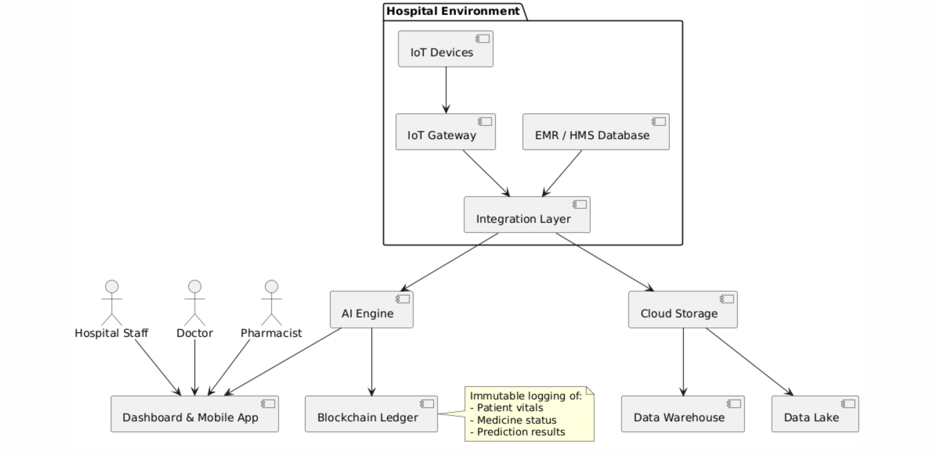

**Fig 3.1: System Architecture**

# DEVELOPMENTAL ENVIRONMENT

* + 1. **HARDWARE REQUIREMENTS**

The hardware specifications could be used as a basis for a contract for the implementation of the system. It is mostly used as a basis for system design by the software engineers.

**Table 3.1 Hardware Requirements**

| **COMPONENTS** | **SPECIFICATION** |
| --- | --- |
| PROCESSOR | Intel Core i3 or higher |
| RAM | Minimum 4 GB RAM |
| STORAGE | 256 GB SS or higher |
| POWER SUPPLY | +5V or UPS Backup |
| DEVICES | IoT sensors, RFID readers |

# SOFTWARE REQUIREMENTS

The software requirements paper contains the system specs. This is a list of things which the system should do, in contrast from the way in which it should do things. The software requirements are used to base the requirements.

**Table 3.2 Software Requirements**

| **COMPONENTS** | **SPECIFICATION** |
| --- | --- |
| Operating System | Windows 10/ Ubuntu 20.04+ |
| Frontend | ReactJS, HTML, CSS |
| Backend | Python Flask Framework |
| Database | MongoDB(NoSQL), SQLite(local) |
| AI libraries | Scikit-learn, TensorFlow, pandas |
| Blockchain Layer | Python-based Blockchain (custom) |
| APIs & Standards | REST API, HL7, FHIR |

# DESIGN OF THE ENTIRE SYSTEM

# 

# ACTIVITY DIAGRAM

# The activity diagram Fig 3.2 represents the workflow of activity which begins when a user submits input - either a patient’s profile or medicine data - via the web/mobile interface. Flask handles this request and routes it through the WSGI server to the appropriate controller. The system then cleans and preprocesses the data and runs it through the trained machine learning models. Depending on the result (e.g., anomaly detected, medicine predicted to run out), the system stores the outcome, writes it to the blockchain and returns the output to the frontend. This process ensure quick, accurate and secure outcomes.

# 

**Fig 3.2: Activity Diagram**

# 3.4.2 DATA FLOW DIAGRAM

The data flow diagram Fig 3.3 shows the movement of information starting from IoT devices and user inputs to data processing and final output generation. First, raw data enters the system from sensors or forms and is sent to a preprocessing unit. After handling missing values and outliers, the data is split into training/testing datasets. Models are trained and tested and final models are deployed into a real-time Flask application. Every prediction is logged on the blockchain and shown to the user. This streamlined process ensures both transparency and scalability.

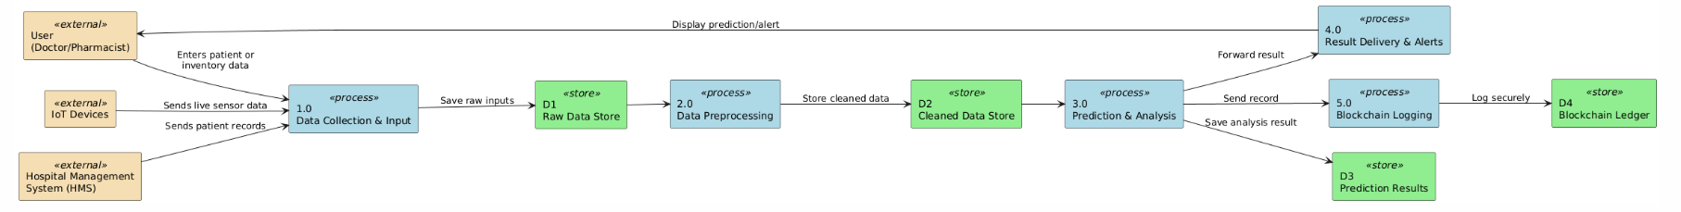

**Fig 3.3:Data Flow Diagram**

* 1. **STATISTICAL ANALYSIS**

The below comparison is between the traditional system and the proposed AI-Blockchain integrated system reveals significant improvements in all key metrics. By incorporating advanced ML models and secure blockchain storage, the system supports real-time decision making and builds trust through immutable recordkeeping. The intelligent combination of analytics, automation and decentralization offers a strong foundation for healthcare modernization.

**Table 3.3 Comparison of features**

| **Aspect** | **Existing System** | **Proposed System** | **Expected Outcomes** |
| --- | --- | --- | --- |
| **Threat Detection** | Manual or rule-based detection | AI-based anomaly detection using Gradient Boosting | High accuracy, fewer false positives |
| **Data**  **Preprocessing** | Basic cleaning | Full-featured pipeline: cleaning, normalization, outlier removal | Improved model performance |
| **Feature Selection** | Manual feature engineering | Automated attribute scoring and dimensionality reduction | Optimized features for better results |
| **Model Optimization** | Rarely tuned | Iterative tuning using grid/random search | Maximized accuracy |
| **Deployment** | Static or delayed inference | Real-time Flask-based microservice | Instant results |
| **Scalability** | Limited to individual systems | Cloud-native and cross-hospital compatible | Scalable across regions |

# CHAPTER 4 MODULE DESCRIPTION

The workflow for the proposed system is designed to ensure a structured and efficient process for detecting and preventing blockchain security threats. It consists of the following sequential steps:

# SYSTEM ARCHITECTURE

# USER INTERFACE DESIGN

# The user interface here is designed for accessibility, simplicity and access based on their roles . Healthcare professionals can view live data of patient status and medicine stock levels, The pharmacists will receive real time alerts about low stock. UI is developed using React JS and styled with CSS for a responsive and consistent experience across devices. The interface is directly linked to backend APIs, ensuring real-time updates and fast interactivity for all stakeholders, including doctors, nurses, pharmacists, and other hospital administrators.

# 

# Fig 4.1: SEQUENCE DIAGRAM

# BACK END INFRASTRUCTURE

# The backend will handle all the logic and interaction in the model.This will have a database layer for strong inventory and patient data, The machine learning layer for performing predictions and the blockchain layer for recording all the immutable logs.Flask is the backend framework running on a WSGI server. Data is fettched by restful API and ml model processes it and which is hosted by sing libraries such as scikit-learn and TensorFlow, and responses are returned to the UI or stored.

# 4.2 DATA COLLECTION AND PREPROCESSING

## 4.2.1 Dataset and Data Labelling

Datasets are collected from old patient data, medicine stock records and with hospital transactions. Each entry is either labeled normal or critical based on the status of the patient and as available or not available in the case of medicines.Labels are manually verified during initial setup and continuously updated through automated processes and feedback using RPA bots

**4.2.2. Data Preprocessing**

The raw dataset undergoes extensive preprocessing, which includes:

* **Data Cleaning**: Removes null or corrupt entries.
* **Missing Value Handling**: Imputes missing values using median/mode.
* **Outlier Removal**: Eliminates extreme values for better accuracy.
* **Feature Scaling**: Normalizes numerical features to uniform scales.

**4.2.3 Feature Selection**

Advanced techniques are used to ensure relevant and optimized feature sets:

Attribute Evaluation: to rank features based on importance.

Dimensionality Reduction : Reducing data complexity while retaining critical features using Principal Component Analysis (PCA) to remove redundant attributes and reduce computational cost

This will improve model’s performance and speeds up predictions especially on systems with low resources

**4.2.4 Classification and Model Selection**

Three main models are evaluated for classification, such as:

Support Vector Machine (SVM): Useful for anomaly detections in small datasets.

Random Forest (RF): Effective for balanced classification tasks.

Gradient Boosting (GB): Used in final deployment due its higher precision and recall on multiclass classification and time-series forecasts.

**4.2.5 Performance Evaluation**

A precision-recall curve and confusion matrix are used in a thorough performance comparison. With greater sensitivity and fewer false positives, gradient boosting performs better than other methods. Performance is optimized through hyperparameter tuning, also known as grid search. The final model is chosen based on the evaluation's findings.

**4.2.6 Model Deployment**

The optimized model is deployed via a Flask-based system(Flask API) .The APIs receive live data, the received data is processed by the model and result is sent to the front end. The system supports continuous inference, ensuring that predictions are available in real time as new inputs arrive.

**4.2.7 Centralized Server and Database**

A centralized NoSQL database (MongoDB) is used to store:

* Raw data
* Preprocessed features
* Model predictions
* Blockchain transaction logs

The server uses secure API endpoints to interact with the UI and other modules. Data integrity, rollback safety, and replication are ensured via robust configuration.

**4.3 SYSTEM WORKFLOW**

**4.3.1 User Interaction:**

Users initiate the verification process by requests through the frontend—either scanning a medicine pack or monitoring a patient’s vitals. The request s are sent to flask backend and processed for prediction or logging

**4.3.2 Fake Stock Detection:**

(For inventory fraud): The model flags abnormalities like sudden stock outs or

unusual repeated scans. These are analyzed and stored for further investigation.

**4.3.3 Blockchain Integration:**

The system will log predictions,critical alerts and verification statues as immutable entries on a blockchain ledger so there will be data transparency and traceability

**4.3.4 Fraud Prevention & Reporting:**

Anomalous activities like overconsumption of medicine will trigger alerts and sent to pharmacists/admins. Reports can be downloaded or forwarded for administrative action.

**4.3.5 Continuous Learning & Improvement:**

New data is continuously added to the training datasets A scheduled retraining pipeline using Apache Airflow updates the model weekly or monthly to improve the detection accuracy.

This modular, scalable, and intelligent architecture ensures a secure and efficient hospital environment where resource wastage is minimized, patient care is enhanced, and staff workload is significantly reduced.

# CHAPTER 5

# IMPLEMENTATION AND RESULTS

# IMPLEMENTATION

Helping Hands is implemented using python as backend and FastAPI for lightweight APIs. React.js and Tailwind CSS is used to create a user-friendly interface.It uses PostgreSQL for structuring hospital data and MongoDB to handle unstructured data. It leverages IoT sensors such as RFID , wearables to gather real time data from the patients and medicine inventory. The device transmits the received data to the gateway which further transmits to the cloud via MQTT. The data streaming and analysis is managed by Apache Kafka. ARIMA, LSTM, XGBoost models are used to predict analysis and send alerts to the hospital personnel for a quicker decision. It is seamlessly integrated with the current HMS by HL7 and FHIR and deployed via Docker and Kubernetes. All the data in the system are provided security protocols with TLS encryption and OAuth 2.0 Authentication.

# OUTPUT SCREENSHOTS

# All of the project's major modules aim to assist the hospital staff in making decisions in real time. As depicted in Figure 5.1, the main dashboard displays an overview of important data like total patients, patients count with those at risk, available medical equipment, and the stock of consumables like medications. This screen also ensures that the staff is informed and aids in prompt action when a patient’s vitals like heart rate or oxygen reading goes beyond safe limits. In addition, doctors and nurses can view the patient's status and provide timely care through the patient details page shown in Figure 5.2. This page contains vital personal and health information which is presented in an easy to read manner so that it can be accessed quickly. Employees tend to keep track of the supply of medications which is under management in the inventory control screen shown in Figure 5.3. They can also note the expiry date of these medications and place refill requests if necessary. To prevent stock void, color coded labels like "Low Stock" are also used to avert shortages before they occur. Then in Figure 5.4, this next module of predictive and alerts is installed to expect patient influx and medication consumption a prior with machine learning techniques which enables the hospital to do prior preparations and the fig 5.5 tells the report and analytics of the patient over time and the utilization of inventory.

Fig 5.1 Dashboard of helping hands

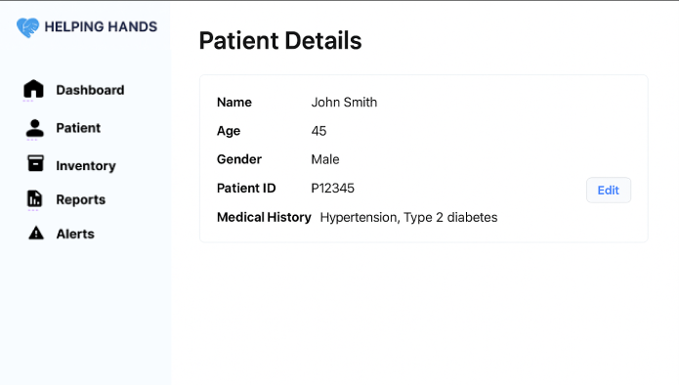

Fig 5.2 Patient Details.

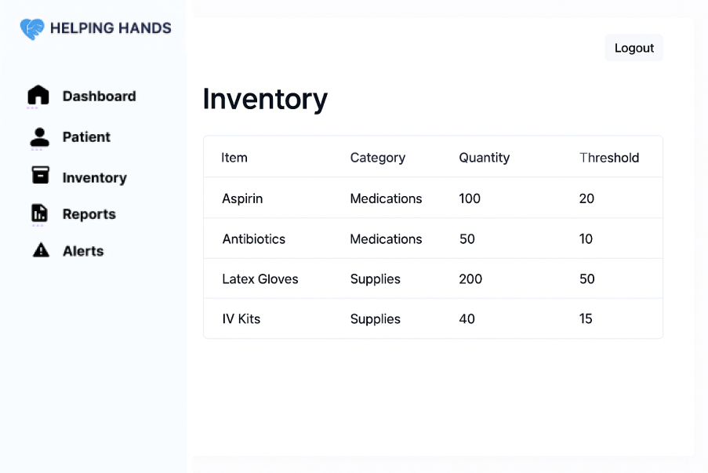

Fig 5.3 Inventory Management

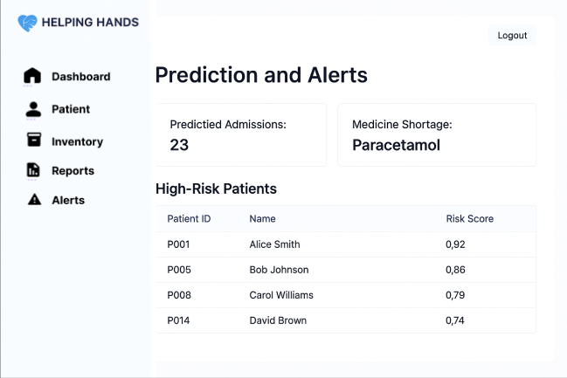

Fig 5.4 Prediction and Alerts

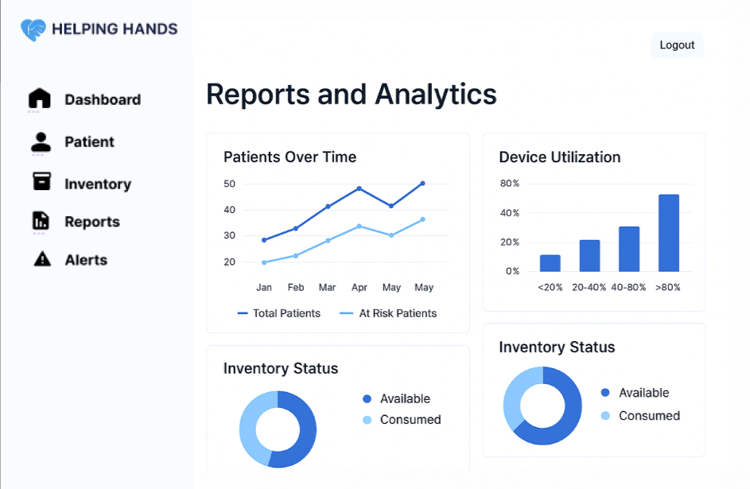

Fig 5.5 Reports and Analytics

**CHAPTER 6**

**CONCLUSION AND FUTURE ENHANCEMENT**

# CONCLUSION

# The "HELPING HAND: AI-Driven Medical System" effectively integrates state-of-the-art technologies like blockchain, machine learning, and the internet of things to offer a robust, scalable, and intelligent solution for real-time hospital operations. The system solves important operational issues that government healthcare facilities face by automating patient health monitoring and medication inventory tracking.

# The platform guarantees 24/7 visibility into patient conditions and stock levels by continuously collecting data from RFID-enabled cabinets and Internet of Things sensors. Accurate forecasts of medication shortages and early identification of health abnormalities are made possible by machine learning algorithms such as Support Vector Machine, Random Forest, and Gradient Boosting. Blockchain integration promotes trust and traceability throughout the healthcare ecosystem by guaranteeing the transparency, security, and immutability of vital data records.Clinicians, pharmacists, and administrators can easily access real-time dashboards and alerts through the system's user interface, which was developed with ReactJS and supported by Flask.

# HELPING HAND makes hospital management a data-driven, proactive process through automated workflows, predictive analytics, and centralized data storage. This project represents a major advancement in the digital transformation of medicine by showcasing how AI and secure cloud infrastructure can be used to develop effective, secure, and responsive healthcare services.

# 

# FUTURE ENHANCEMENT

Future improvements can increase the current system's capabilities even though it offers dependable and significant functionalities:

* Using sophisticated neural network models, such as CNNs (for image-based patient monitoring) and LSTMs (for sequential vitals prediction), to increase diagnostic precision is known as deep learning integration.
* Multi-Hospital Deployment: Developing a networked healthcare ecosystem by extending the system to facilitate federated data exchange between hospitals.
* Smart Contract Implementation: Using blockchain-based smart contracts to enable automated triggers for medication refills or raising patient alerts.
* Decentralized Identity (DID): Using blockchain credentials to add a decentralized user identity verification system for employees and patients in order to guarantee authenticity and privacy.
* Cross-Platform Support: Adding offline data caching for remote or resource-constrained locations and expanding the mobile application for iOS devices.
* Speech/Voice Recognition Interface: Using AI-powered voice assistants, doctors can now interact hands-free for faster access during rounds.
* AI Chatbot Integration: Including an AI chatbot in the dashboard to respond to user inquiries, recommend therapeutic courses of action, or provide navigation through the features of the application.
* Real-Time ICU Monitoring: Improving the platform to enable ongoing ICU monitoring with automated prioritization and severity grading according to real-time vitals.
* Data Analytics for Policy Making: Combining anonymized data to help healthcare policy makers spot patterns in regional outbreaks, patient admissions, and medication use.

These enhancements will help the system to adapt for future technological enhancement and evolving health care needs

# REFERENCES

Sahoo, J., Mishra, S., & Pati, B. (2023). *IoT-Based Real-Time Health Monitoring System Using Cloud and AI*. Journal of Healthcare Informatics Research, Springer.

Kumar, R., & Singh, D. (2022). *Machine Learning Algorithms for Predictive Healthcare Analytics*. International Journal of Computer Applications.

Rahman, M. A., et al. (2023). *Anomaly Detection in Healthcare Using Gradient Boosting and Time-Series Forecasting*. IEEE Transactions on Computational Biology and Bioinformatics.

L. C. Scabora, et al., “Physical Data Warehouse Design on NoSQL Databases OLAP Query Processing over HBase,” in Proc. 18th Int. Conf. on Enterprise Information Systems, Rome,

Baldimtsi, F., et al. (2024). *zkLogin: Privacy-Preserving Blockchain Authentication with Existing Credentials*. Proceedings of the 2024 ACM SIGSAC Conference.

The Medical Project Management (MPM) System .A semantic middleware for a unified representation of medical recordsAhmed Dridi1, Anis Tissaoui2 and Salma Sassi3

F. Gao, et al., “Geospatial Data Storage Based on HBase and MapReduce,” in Proc. Agro-Geoinformatics, 6th Int. Conf. on IEEE, Fairfax, .

Xingdan, Yao Junming. Medical health data: concepts, characteristics, platforms and data integration [J]. Internet of Things Technologies.

Sarmah, S. S. (2018). *Understanding Blockchain Technology*. Computer Science and Engineering, .

Xingdan, Yao Junming. Medical health data: concepts, characteristics, platforms and data integration [J]. Internet of Things Technologies.

Duan Jinning. Application of healthcare big data in the"Internet+"medical

environment [J]. Chinese Journal of Medical Library and Information Science.

Fei Xiaolu, Li Jia, Huang Yue, et al. Data governance practice in medical big data application [J]. Chinese Journal of Health Informatics and Management, 2018.